# CS 255 System Design Document Template

## UML Diagrams

**Corey Harvey**

### UML Use Case Diagram

### UML Activity Diagrams

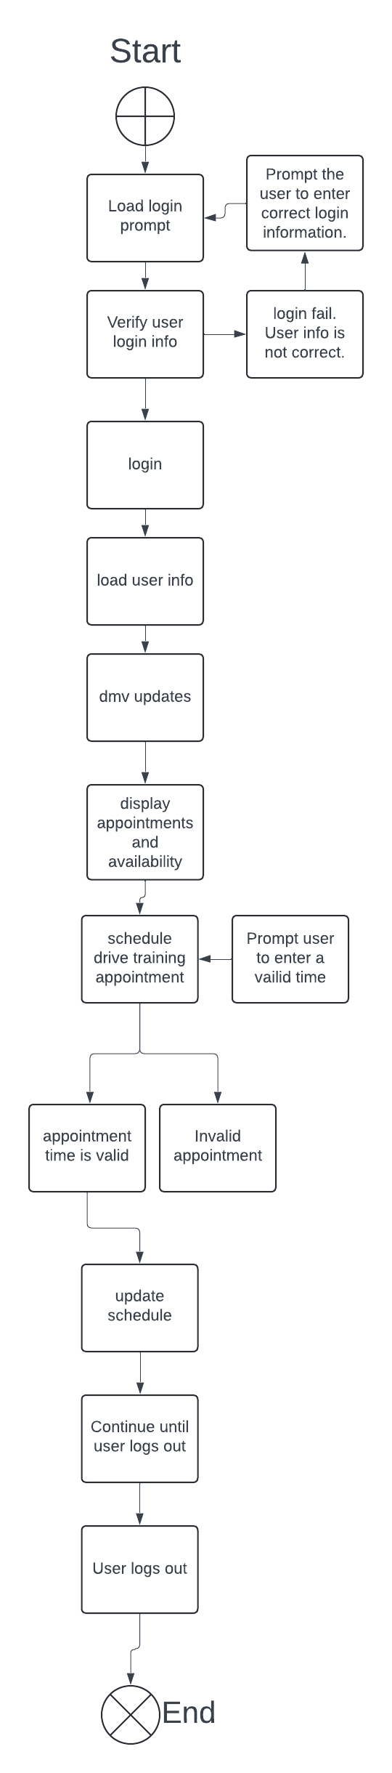

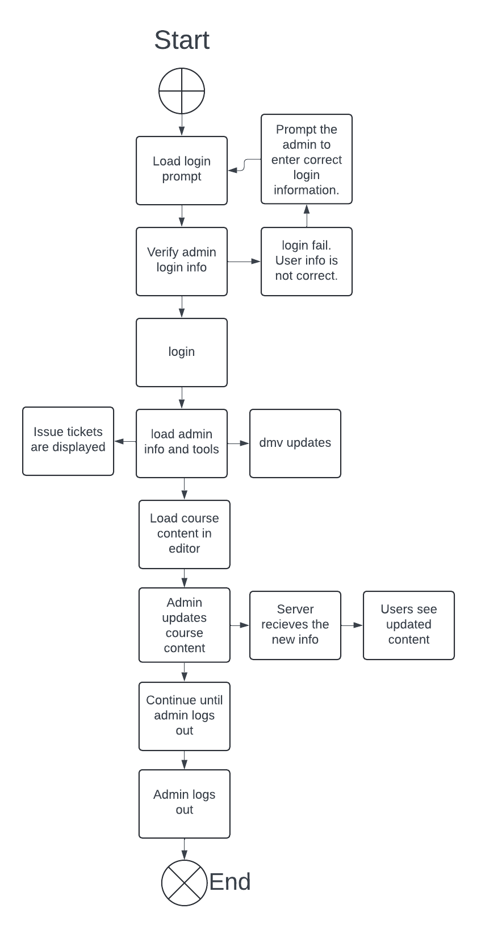

### UML Sequence Diagram

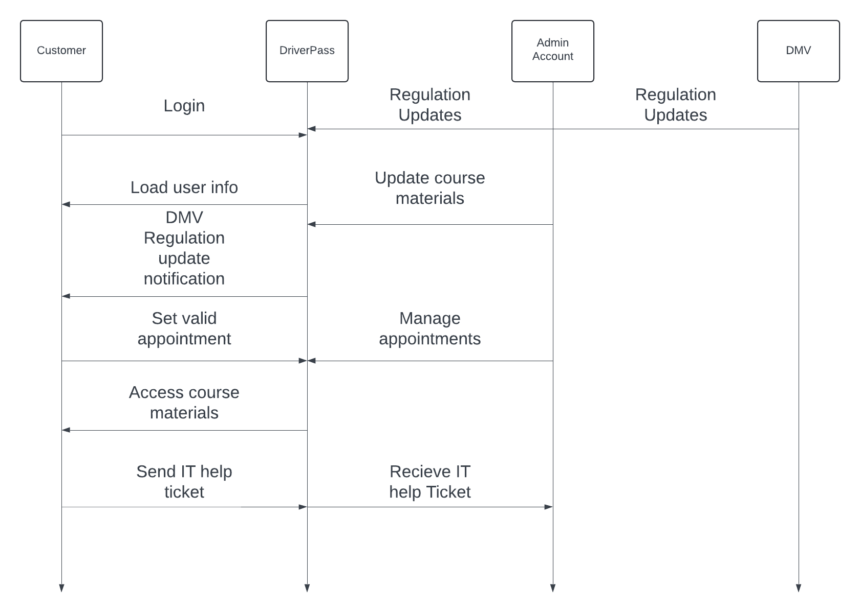

### UML Class Diagram

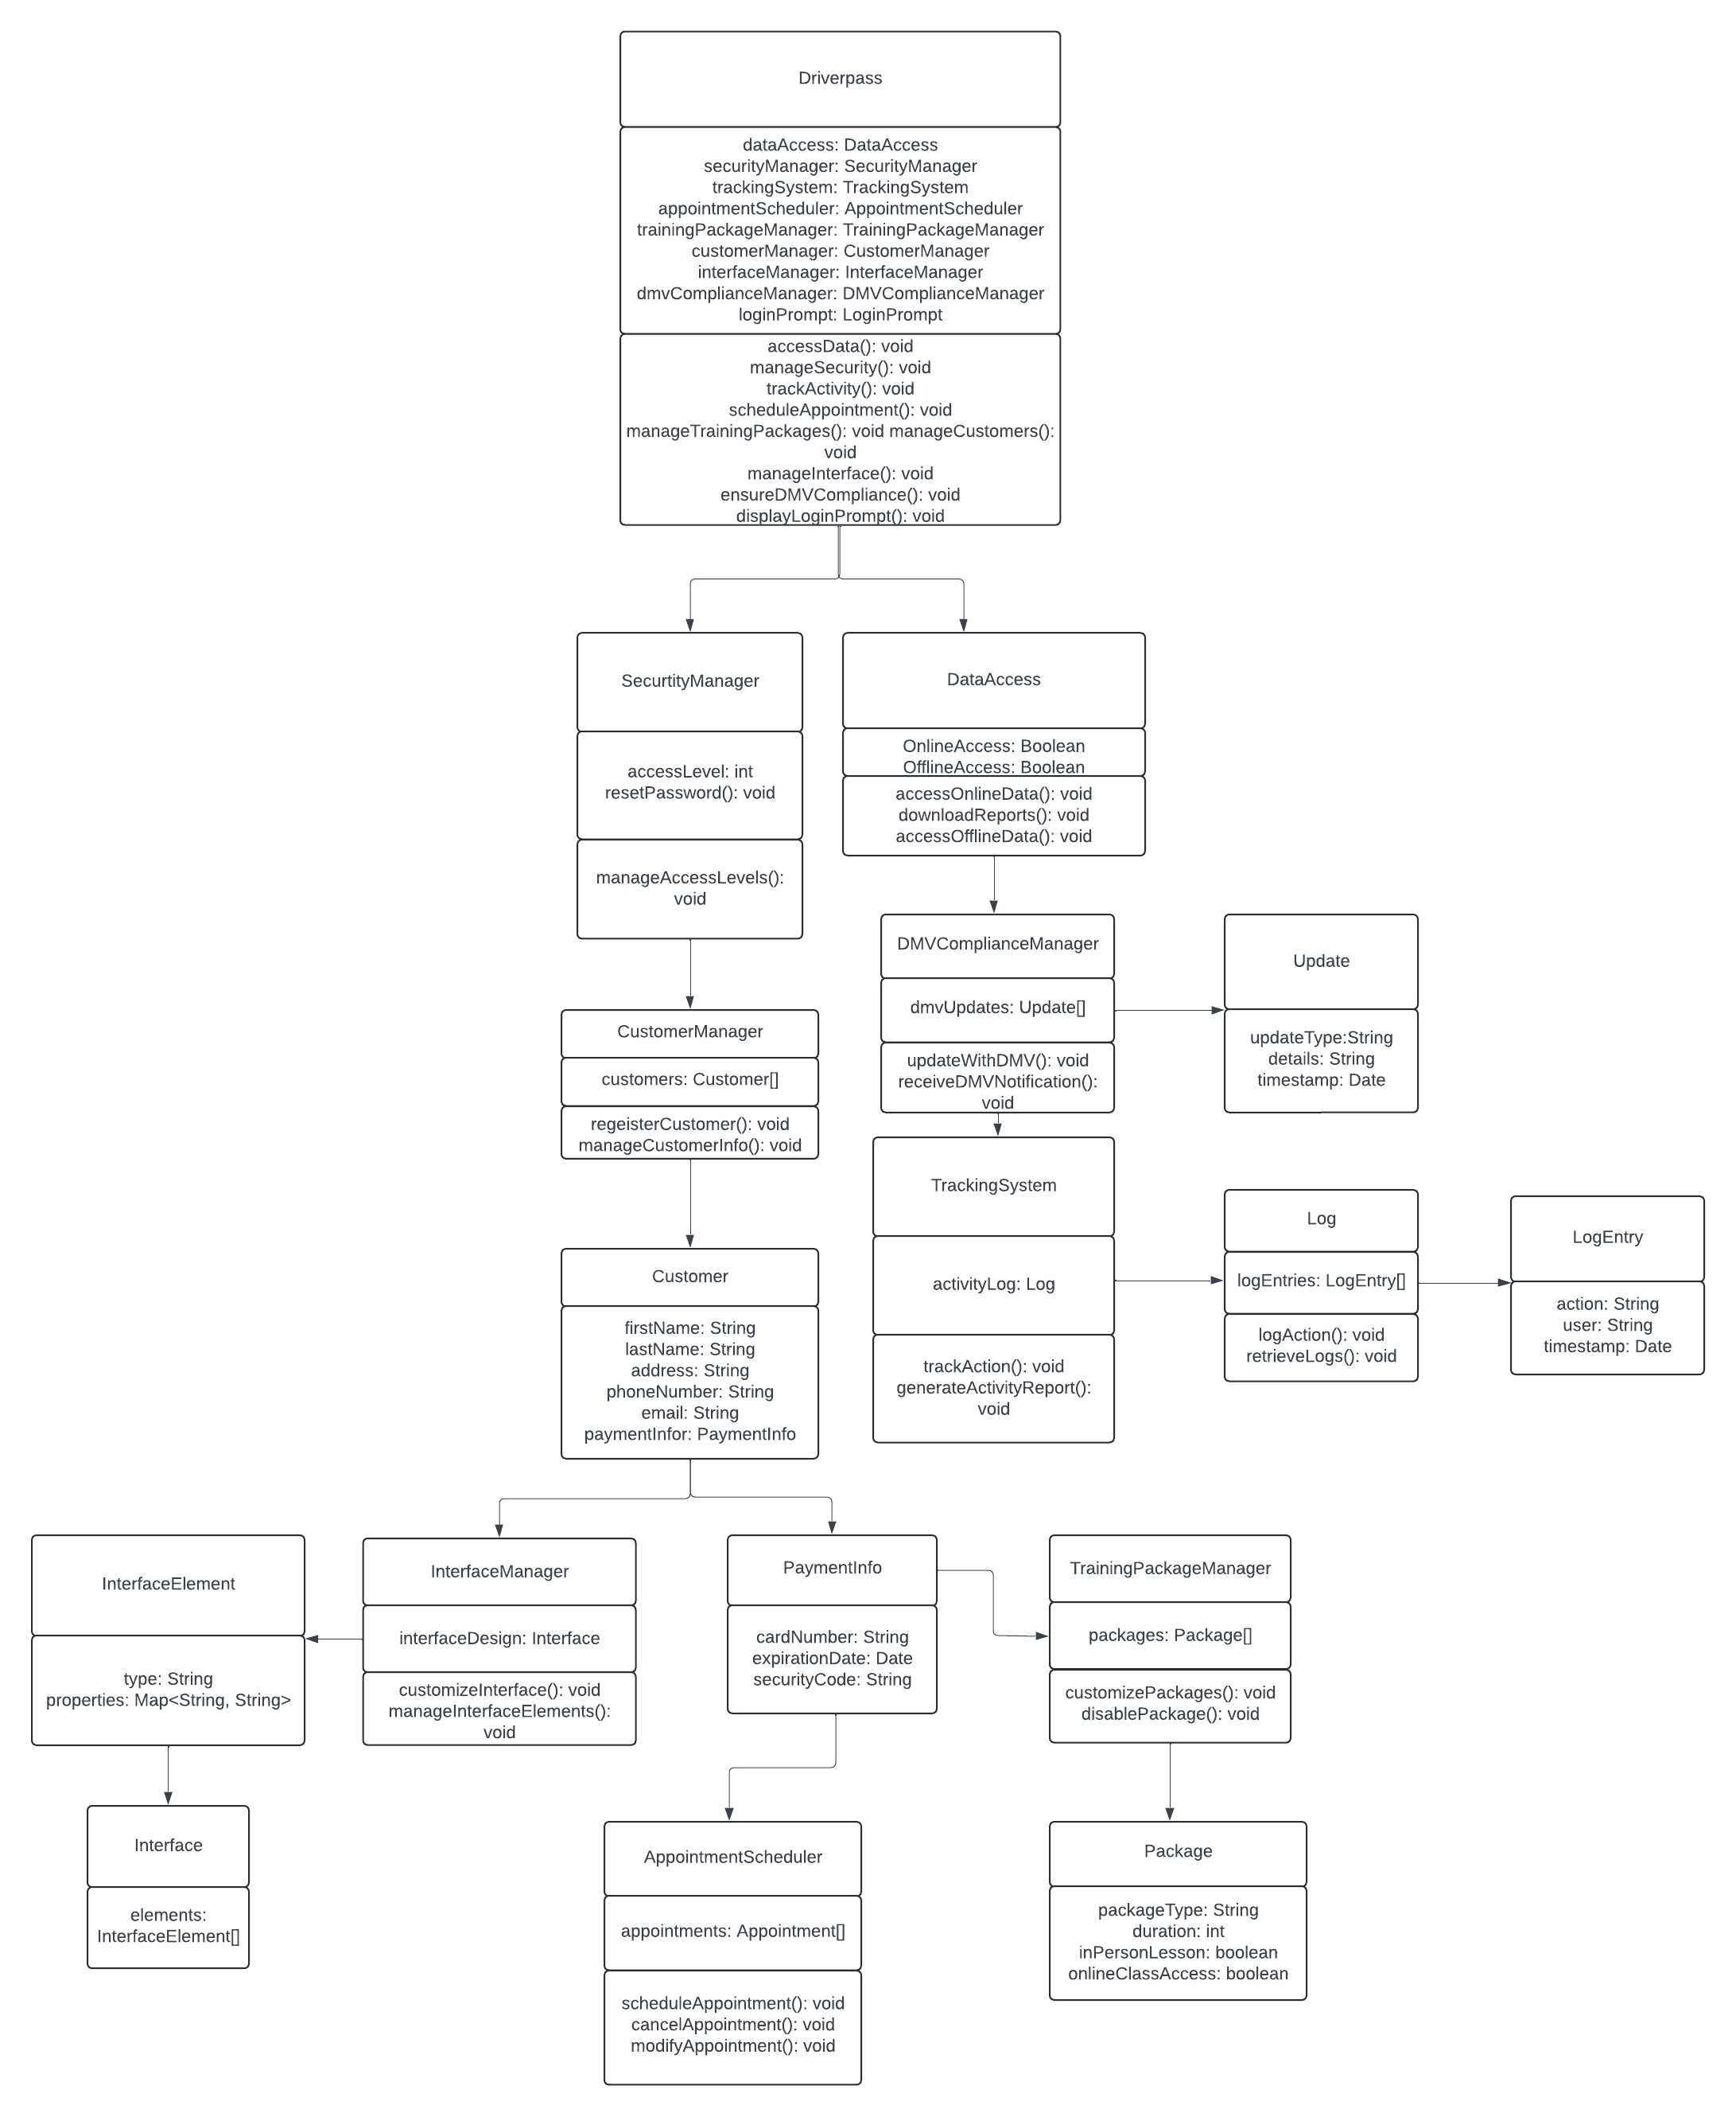

## Technical Requirements

**Servers and hosting hardware:**A server will be needed along with the hardware that the server will need. This will be what does all the processing and storing from the requests by all the DriverPass users. It will provide and receive all information on DriverPass. It is the center of the system.

**Networking Equipment and hosting services:**  
A DNS and other networking services will need to be paid for. Services like Godaddy and others of the like offer what is needed and will need to be paid for regularly to keep everything running outside of a local environment. This includes all the software and software configuration needed for the server to run.

**Storage and backup:**A drive rack will likely be needed to host all user information on multiple storage units for a database hosted by the server. The server will need active drives and backup drives to ensure there is no downtime. Raid configurations will help a lot in this situation and need to be discussed by the team.

**Operating system:**We will need an operating system to run virtual machines that will ensure that if an operating system is down, the entire server’s functions don’t go down with it. ESXI should suffice and is a personal preference. A bare metal setup is not needed here.

**Web Development Framework:**We need a way to build and maintain the website. We need to ensure compatibility with browsers. The compatibility with future browsers can be checked by downloading and testing experimental versions of each browser. We need something that can handle login information securely.

**Database:**We will need a database to ensure that all information can be accessed and written. We need to use this to keep track of as much information as possible. This can store transaction data and user information.

**Security tools:**Encryption and security is needed in an online environment. We need to protect user data as much as possible. We need to protect our own data as much as possible as well.